FREQUENCY SWEEP WITH OFFSET
  - Sine and Triangle Wave Performance from 10 Hz to 200 kHz
Project | PocketLab BLE-Controlled Function Generator
Test configuration | 1.00 Vpp, 2.35 V commanded offset, output enabled
Signal path | AD9833 → 47 µF coupling → X9C103S → OP484
Test date / operator | July 16, 2026 / Mark Anderson

Executive Summary
RESULT: PASS WITH CHARACTERIZED LIMITATIONS. The offset-enabled analog path remained bounded and stable throughout the sweep. No clipping, rail excursion, or frequency-dependent baseline movement was observed at the tested 1 Vpp setting. The measured center was approximately 2.30 V rather than the commanded 2.35 V, indicating a repeatable calibration offset of about −50 mV.
Both waveforms showed moderate low-frequency amplitude loss at 10 Hz and increasing ripple/distortion above 10–50 kHz. Sine amplitude remained nearly flat through 200 kHz, although waveform fidelity was poor at 100–200 kHz. Triangle amplitude began to decline above 50 kHz and its shape was poor by 100–200 kHz.

1. Objective
Evaluate amplitude, DC offset, waveform shape, and phase behavior with offset control enabled at representative frequencies from 10 Hz to 200 kHz. Special attention was given to the low-frequency response of the 47 µF AC-coupling capacitor and to high-frequency waveform degradation.

2. Test Configuration
Parameter | Setting
Waveforms | Sine and triangle
Commanded amplitude | 1.00 Vpp
Commanded offset | 2.35 V
Frequencies | 10 Hz, 100 Hz, 1 kHz, 10 kHz, 50 kHz, 100 kHz, 200 kHz
Oscilloscope coupling | DC
Channel 1 | X9C wiper / OP484 input
Channel 2 | OP484 output
Acquisition | 16 Ki samples; timebase and sample rate adjusted by frequency

Amplitude was taken from the Channel 2 peak-to-peak measurement. Offset was recorded using the Channel 2 average. WaveForms automatic phase measurements are retained as approximate values; their reliability decreases when the waveform is noisy or strongly non-sinusoidal.

3. Sine-Wave Results
Frequency | Vpp (V) | Average (V) | Min–Max (V) | Phase | Shape
10 Hz | 0.932 | 2.299 | 1.834–2.765 | 0.34° | Clean; low-frequency attenuation
100 Hz | 0.956 | 2.299 | 1.821–2.778 | 2.72° | Clean; amplitude recovering
1 kHz | 1.061 | 2.299 | 1.765–2.826 | 12.71° | Clean fundamental; visible noise
10 kHz | 1.073 | 2.299 | 1.762–2.835 | 14.02° | Sine retained; periodic ripple
50 kHz | 1.077 | 2.300 | 1.759–2.836 | 14.30° | Strong ripple/distortion
100 kHz | 1.063 | 2.300 | 1.765–2.828 | 15.03° | Considerable distortion
200 kHz | 1.068 | 2.298 | 1.755–2.823 | 18.93° | Poor sine fidelity; no clipping

Sine amplitude increased from 0.932 Vpp at 10 Hz to approximately 1.06–1.08 Vpp from 1 kHz upward. The output average remained within 2.298–2.300 V at all test frequencies.
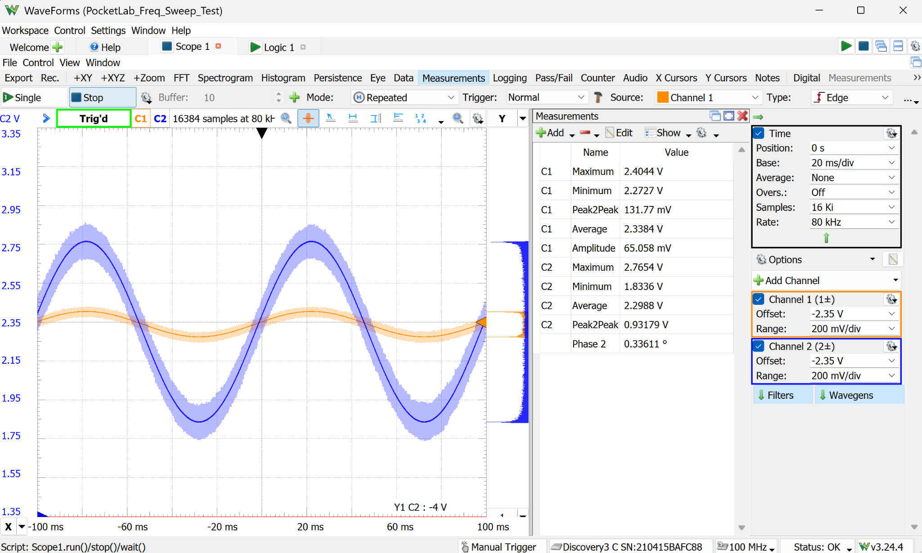
Figure 1. 10 Hz sine: clean, stable baseline with 0.932 Vpp output.
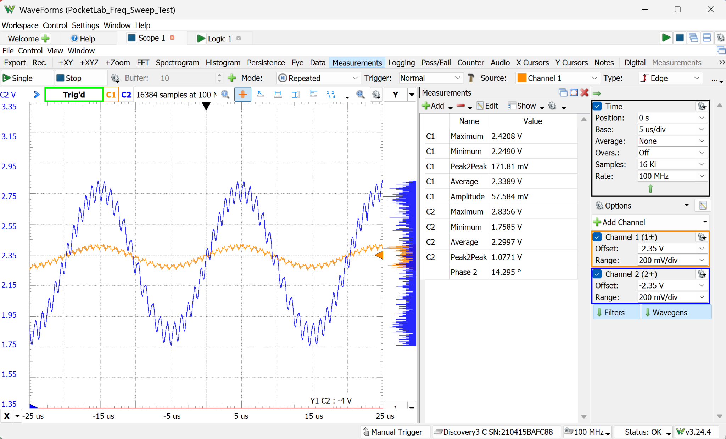
Figure 2. 50 kHz sine: amplitude retained, but periodic ripple is prominent.
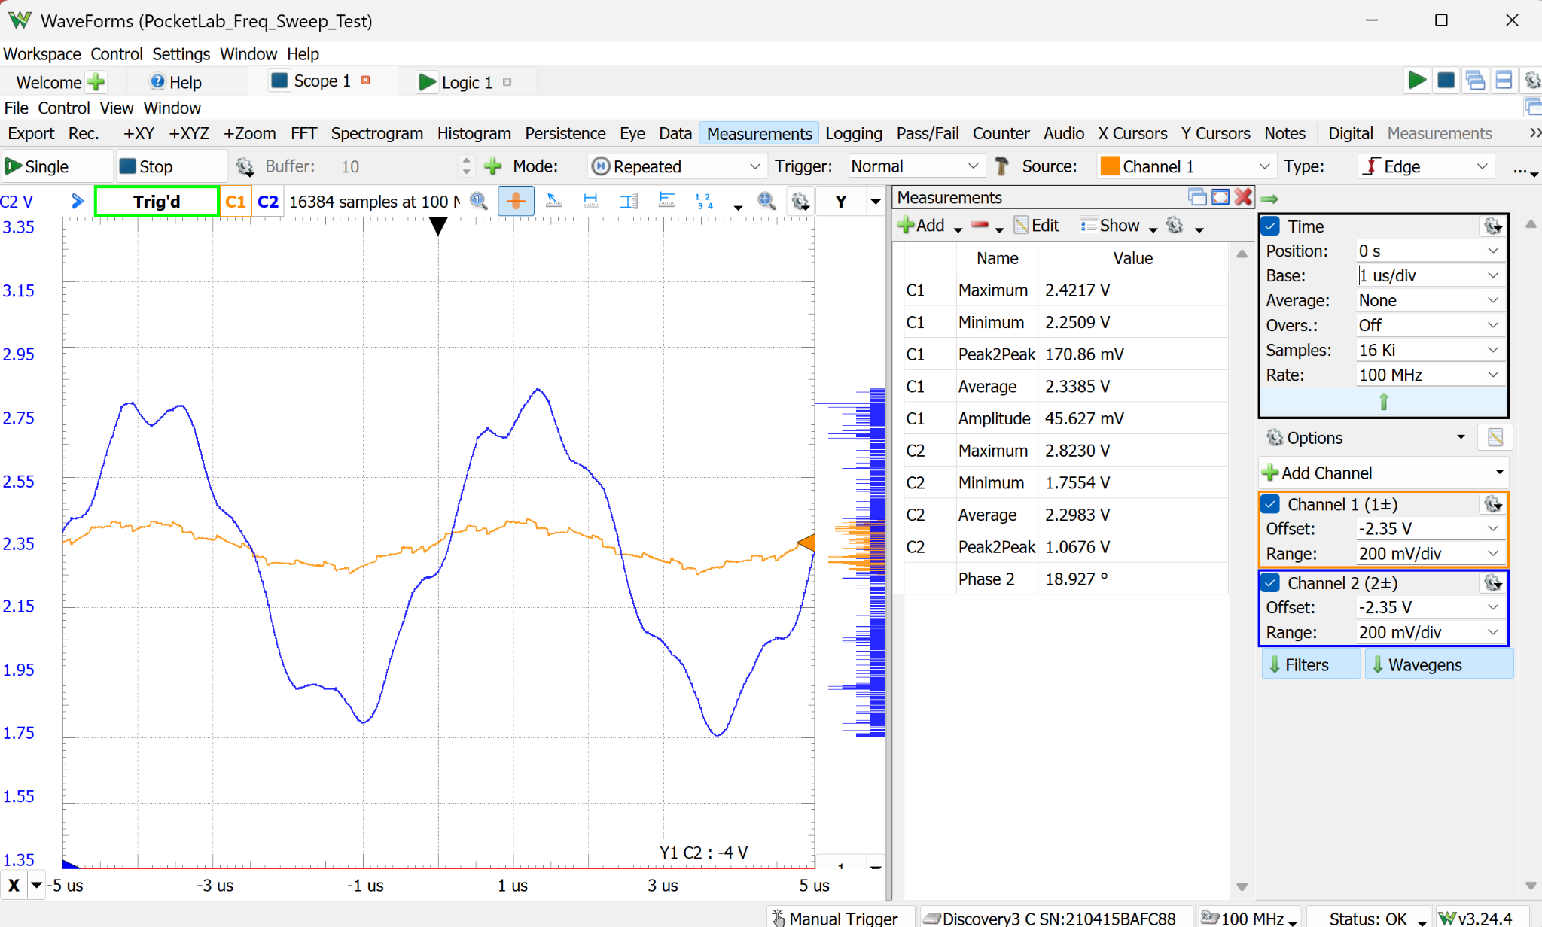
Figure 3. 200 kHz sine: substantial shape distortion without clipping.

4. Triangle-Wave Results
Frequency | Vpp (V) | Average (V) | Min–Max (V) | Phase | Shape
10 Hz | 0.930 | 2.299 | 1.835–2.765 | 0.40° | Clean, straight slopes; attenuated
100 Hz | 0.953 | 2.299 | 1.822–2.776 | 3.25° | Clean triangle
1 kHz | 1.060 | 2.299 | 1.767–2.826 | 15.44° | Clean shape; noisy trace
10 kHz | 1.060 | 2.299 | 1.765–2.825 | 16.97° | Triangle retained; strong ripple
50 kHz | 1.059 | 2.291 | 1.768–2.827 | 17.46° | Triangular envelope; corrugated
100 kHz | 1.021 | 2.300 | 1.772–2.793 | 18.32° | Uneven slopes; considerable distortion
200 kHz | 1.009 | 2.298 | 1.789–2.799 | 22.17° | Rounded/irregular; poor fidelity

Triangle amplitude matched the sine response at low and mid frequencies, then declined to 1.021 Vpp at 100 kHz and 1.009 Vpp at 200 kHz. The triangular envelope remained recognizable at 50 kHz, but ripple and peak irregularity dominated at 100–200 kHz.
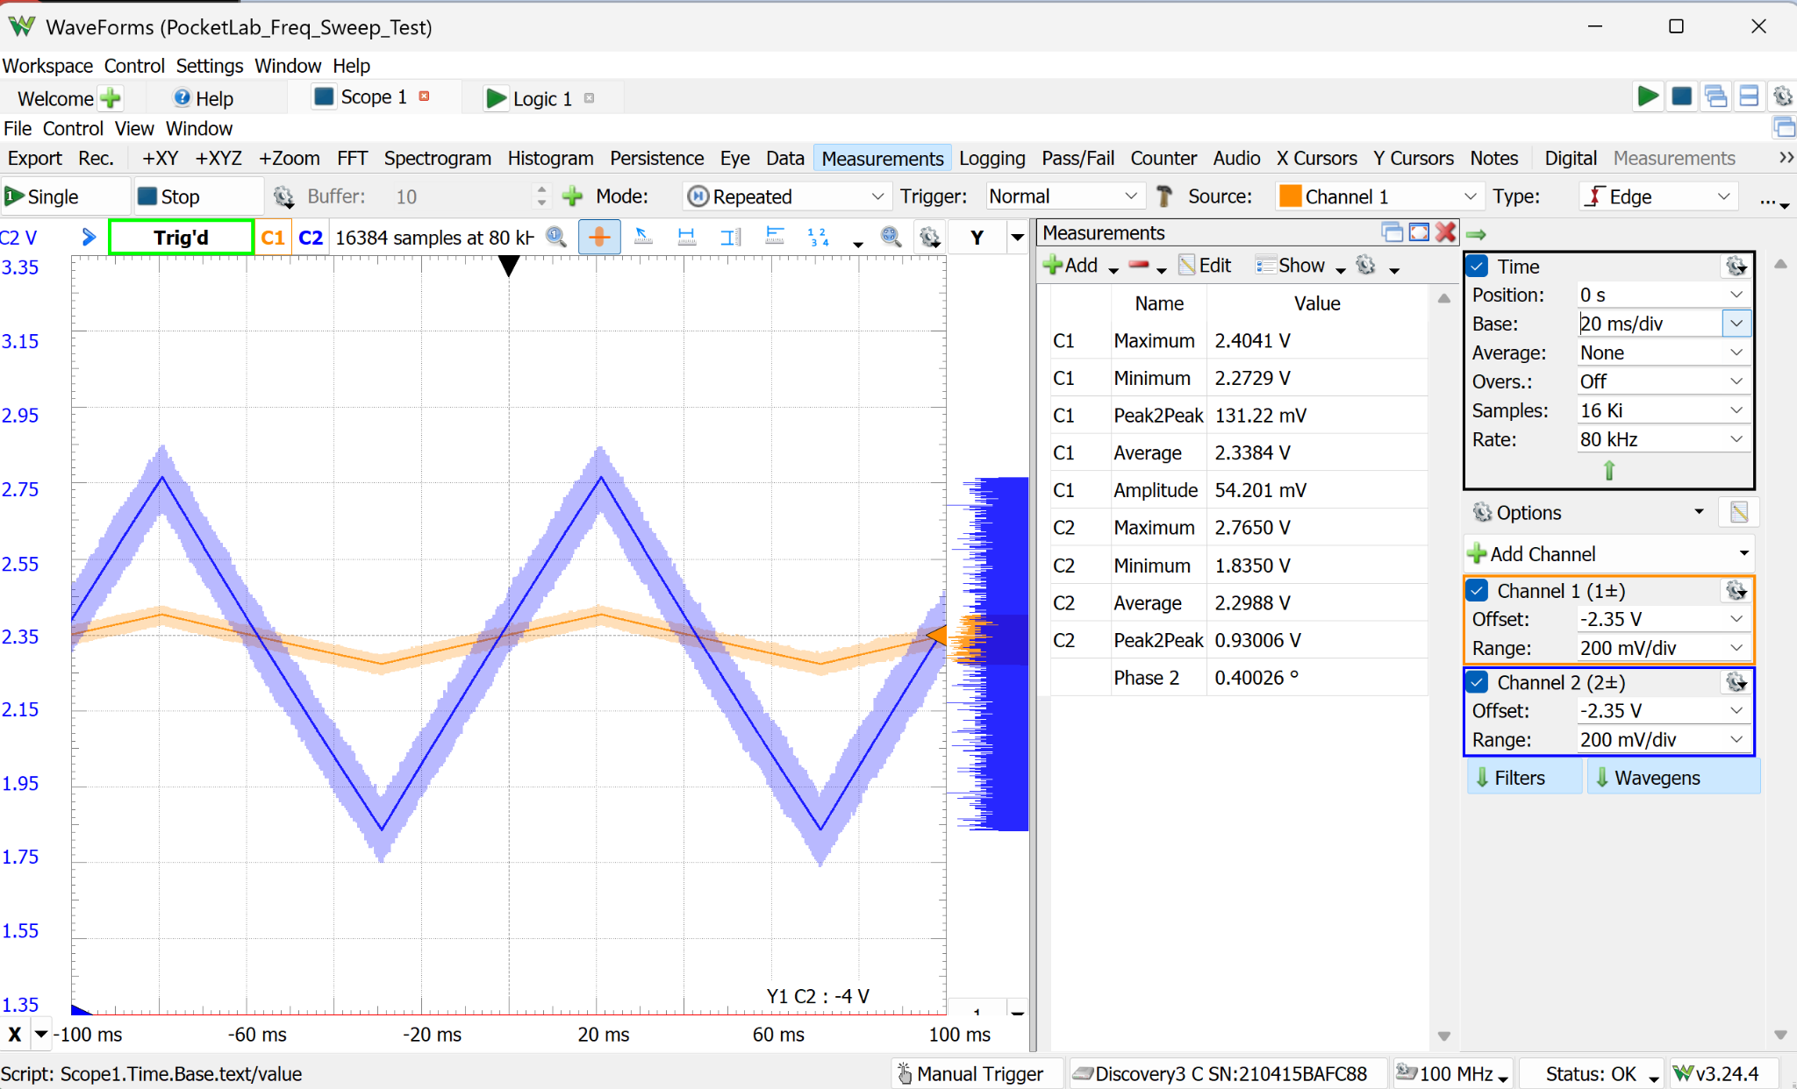
Figure 4. 10 Hz triangle: straight slopes, stable center, and 0.930 Vpp output.
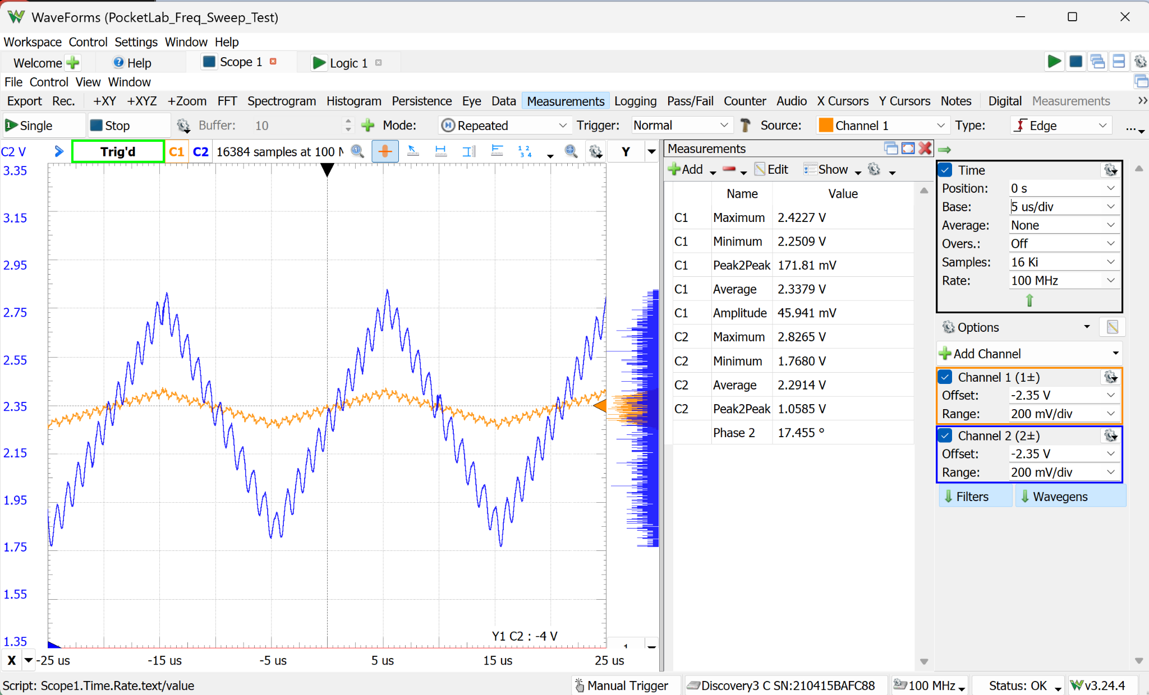
Figure 5. 50 kHz triangle: triangular envelope retained with severe ripple.
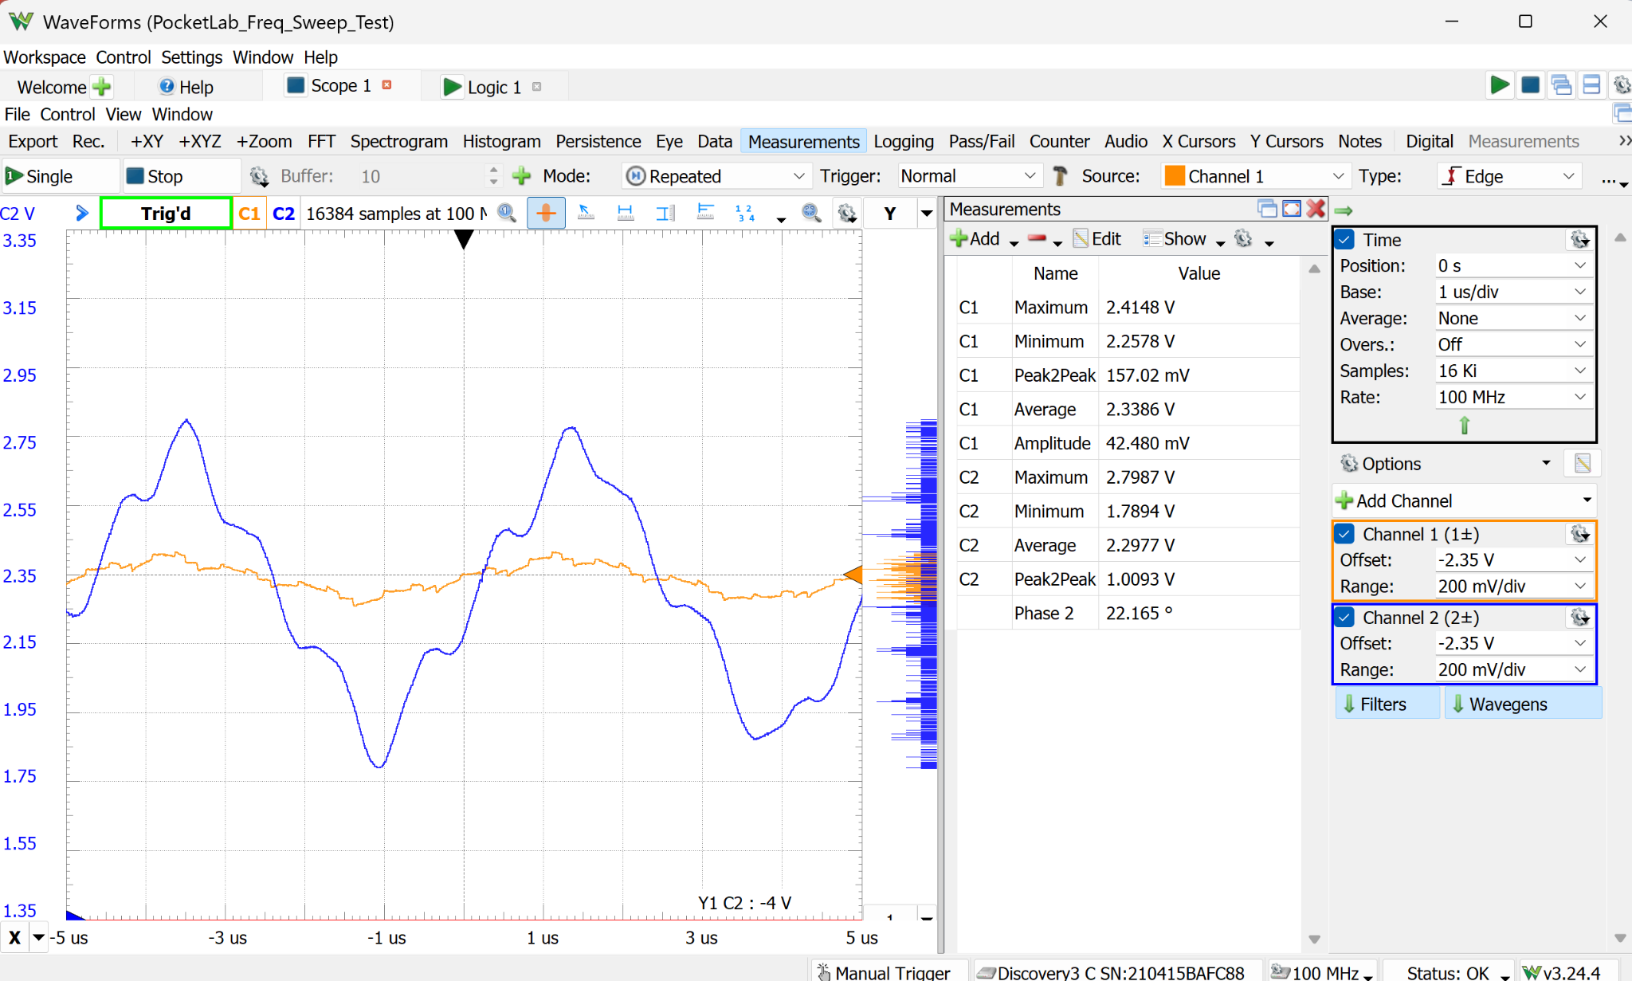
Figure 6. 200 kHz triangle: rounded, irregular peaks and poor waveform fidelity.

5. Analysis

5.1 Low-Frequency Coupling Response
Using the observed midband amplitudes as the reference, the 10 Hz sine result is approximately 13.5% below the 50 kHz sine amplitude (about −1.25 dB). The 10 Hz triangle result is approximately 12.3% below its 1–50 kHz midband value (about −1.13 dB). The 100 Hz results remain roughly 10–11% below midband.
The 47 µF coupling capacitor therefore provides usable 10 Hz operation, but it does not produce fully flat amplitude response at the low-frequency limit. Importantly, neither waveform showed obvious baseline tilt, slow movement, or loss of DC-offset control after settling.

5.2 Offset Accuracy and Stability
The requested center was 2.35 V. Nearly all output averages measured 2.298–2.300 V, with one 50 kHz triangle capture reading 2.291 V. The approximately −50 mV systematic error is small and stable, suggesting DAC/reference/path calibration rather than frequency-dependent baseline movement.

5.3 High-Frequency Fidelity
Periodic ripple was visible on Channel 1 and amplified on Channel 2, indicating that a substantial portion originates before the OP484 output—within or around the AD9833, X9C103S, wiring, grounding, or breadboard signal path. Amplitude measurements alone therefore overstate usable high-frequency performance: magnitude remains near target while waveform purity deteriorates.

5.4 Phase Behavior
The automatic phase reading increased with frequency, reaching approximately 19° for the 200 kHz sine and 22° for the 200 kHz triangle. These readings are best treated as trend indicators. The small, noisy Channel 1 signal and the harmonic content of distorted triangle waves reduce the validity of a single automatic phase value.

6. Acceptance Assessment
Criterion | Status | Evidence
No unsafe rail excursion | PASS | All outputs remained between approximately 1.75 V and 2.84 V.
Offset stable versus frequency | PASS | Output average remained near 2.30 V across both sweeps.
1 Vpp amplitude at 1 kHz | PASS / CAL | Measured approximately 1.06 Vpp; calibration can remove the gain error.
Usable 10 Hz output | PASS WITH LOSS | Clean waveform and stable baseline; approximately 12–14% attenuation.
High-frequency amplitude retention | PASS | Sine remained near 1.06–1.08 Vpp through 200 kHz.
High-frequency waveform fidelity | LIMITED | Visible degradation above 10–50 kHz; poor at 100–200 kHz.

7. Conclusions and Recommended Follow-Up
- Retain the 47 µF coupling capacitor for the current prototype; its 10 Hz response is usable and does not cause baseline instability.
- Add frequency-dependent amplitude calibration only if accurate 1.00 Vpp output at 10–100 Hz is a product requirement.
- Calibrate the DAC/offset transfer so a 2.35 V command produces approximately 2.35 V at the output rather than 2.30 V.
- Prioritize high-frequency noise investigation around grounding, supply decoupling, the X9C103S path, AD9833 clock feedthrough, and breadboard parasitics.
- Use a sine-wave FFT or residual-noise measurement in a later test to quantify the periodic ripple and identify its dominant frequency.
- Treat 100–200 kHz as amplitude-capable but not high-fidelity operation in the present breadboard implementation.
Final disposition: The offset-enabled frequency sweep passed the safety and baseline-stability objectives. Low-frequency attenuation and high-frequency distortion are characterized limitations for subsequent calibration and signal-integrity work.

